Question 2

12 points

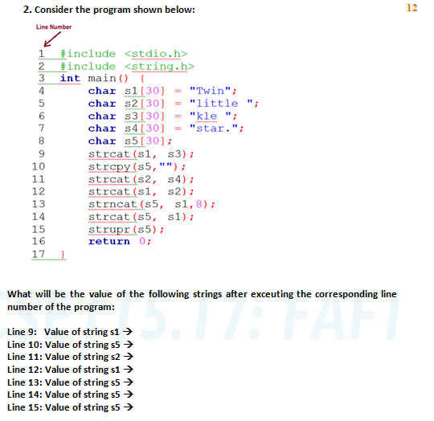

Line 9: Value of string s1 🡪 Twinkle

Line 10: Value of string s5 🡪 “”

Line 11: Value of string s2 🡪 little star.

Line 12: Value of string s1 🡪 Twinkle little star.

Line 13: Value of string s5 🡪 Twinkle

Line 14: Value of string s5 🡪 Twinkle Twinkle little star.

Line 15: Value of string s5 🡪 TWINKLE TWINKLE LITTLE STAR.